Multiclass ECG signal Classification using Artificial Neural Network.

Shraddha Kapse, kapseshraddha25@gmail.com

Sanket Naik, sanketn7941@gmail.com

Sunnyclive Francis,sunnyfrancis73@gmail

Devashri Joshi, Professor, devashri.joshi@viit.ac.in

Department of E&TC Engineering, VIIT, Pune.

***ABSTRACT: -***

**An electrocardiogram (ECG) is widely used in medical field to measure the electrical activity of human heart by placing electrodes on the skin of patient’s body. The purpose of this paper is to classify ECG signal using ANN for cardiac arrhythmia detection, using multi-channel ECG signal. For classification of ECG signal into multiple classes e.g. Fusion, PVC and Normal, we used neural network model using back propagation algorithm. Feature extraction techniques have been used to extract important features of ECG waveform by using ANN, for that we used Discrete cosine transform (DCT). The technique used in this paper integrates the study of the hardware raspberry pi for ECG signal data acquisition & their classification for training & testing purpose.**

**KEY WORDS:- Artificial Neural Network, ECG, DCT, Feature Extraction.**

1. **INTRODUCTION**

The heart’s electrical activity is observed using ECG, by placing electrodes on the surface of limbs & chest. An Electro Cardio Gram (ECG) is very important tool for diagnosis of heart diseases. The heart rate is measure in beats per minute (BPM). As Bio-signals are non-stationary signals, the reflection may arrive at any moment on the time-scale. Each and every Person has different ECG waveform which is different from others. But there are some common characteristics for different types of heart diseases. Therefore the purpose of multiclass ECG signal classifier is to classify the diseases based on the important characteristics of ECG signal to make the diagnostics easy. This can be achieve by using one of the popular method known as artificial neural networks (ANN). ANN is used because computer based systems are more accurate and reliable than manual systems [5].

The ECG signal consists of three main elements i.e. P wave, QRS complex and T wave . The parameters which are useful in comparing the ECG signal of patient with the standard ECG signal are shape, size, duration between each interval and relation between P wave, QRS complex and T wave. Any change in these parameters will affect the normal working of human heart and this give rise to certain heart diseases This irregularities in the ECG wave is called as arrhythmia and many of them are very harmful which may cause death of patient [1].

 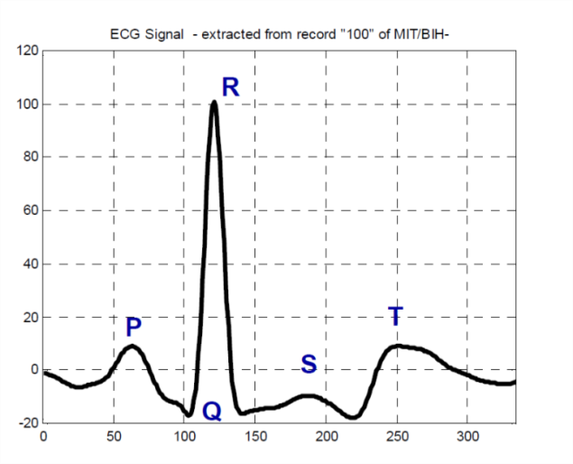

**Figure 1. Types of Heart Beats. Figure 2. ECG signal.**

1. **LITERATURE SURVEY**

So far, many algorithms have been developed in past few years, for detection and classification of ECG. Dayong et.al. developed an arrhythmia detection system on ECG signals based on Bayesian ANN Classifier and its performance is compared with that of other classifiers, specifically Naive Bayes, Logistic Regression, RBF Networks and Decision trees. A review of classification methods suitable for ECG signals can be found in [1]. Ramli et al. [2] used a cross correlation analysis technique to extract the important features from 12 lead ECG signal. By Using the cross techniques the identified values can be used to predict the type of arrhythmias. Manpreet kaur and Arora [3] proposed the K-means clustering with Squared Euclidean distance for the analysis of ECG signals. For feature extraction the parameters identified as wave shape, duration and amplitude. Using K clustering technique clustered K is summed and minimizes the sum of point to centroid distance.

1. **METHODOLOGY**

In this project, the methodology used for classifying the abnormalities of ECG signal and working of each block is given below.

**I. Collection of data**

In this project, we have used MIT-BIH arrhythmia database downloaded from physionet.org [6][7]. The database consists of 180 samples from 200 patients studied by the BIH Arrhythmia Laboratory.

if we use entire 180 samples in training of an ANN ,then we have to face two major problem and they are over trained and computational overhead . Overtraining degrade the performance of the system whereas computational overhead limits speed and resources required .So only required samples should be extracted so that can be used in training of an ANN and it also avoid the problem of overtraining and overhead. [8]

**II. Feature Extraction**

DISCRETE COSINE TRANSFORM(DCT)

DCT is powerful transform technique which is used to extract important features of ECG waveform.

$Y[u]=a[u]\sum_{n}^{N-1}{x[n]\frac{π\cos\left(2n+1\right)u}{2N}}$ (1)

$a[u]=\sqrt{\frac{2}{N} }$**for u≠0** (2)

$a[u]=\sqrt{1/N}$**for u=0** (3)

Where N is the length of the signal.

The advantage of DCT over other data compression algorithm is because of the energy compaction property of DCT represents the data in the lower dimension. So, that the value which are near to zero can be removed and only those point which are related from data set are used to reduced computational overhead. We have taken only 30 values from dataset for training of an ANN.

**III. Training & Learning**

Artificial neural network was developed and introduced by neurophysiologist Warren Mcculloch and logician Walter pits in 1943. ANN resembles to biological human neuron, that is useful in various areas, which are, pattern recognition and classification. An ANN is made up of interconnected processing with consist of summing point and an output the process unit compute output according to N input values, weight, and their sums (sum of the product of the input and corresponding weight).

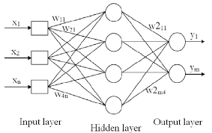

**Figure 3. Multilayer perceptron**

The weighted sum which is the activation value on which the output is based. In this paper we have used feed forward back propagation algorithm which is based on supervised learning. In supervised learning set of inputs and outputs are given and training algorithm adopt the weight in such a way to produce exact output which is similar to desired output .The learning process has ability to reduced overall error to minimum. The neural network is shown in the Fig:-3

The above figure shows ANN which consist of input layer, hidden layer, output layer. The features extracted from dataset are feed as input neuron to ANN. The available data can be used recursively, until the error function is reduced to a minimum. The activation function used in hidden layer is the standard sigmoid function. In the output layer, diseases are classified in three classes i.e. [100] for normal,[010] for PVC and [001] for fusion.

***1 .BACKPROPAGATION ALGORITHM***

Algorithm of back propagation involves following steps. [1]

***1. Initialization of Weights:***

**a)** Initialize the weights and biases to small random values.

**b)**If stopping condition is false, do steps b-j.

**c)** For each training pair ,do steps d-i.

***2. Feed Forward:***

**d)** Each input unit receives the input signal Xi i.e.X0,X1,X2.......................XN-1.And transmit this signal to hidden layer.

**e)** For each hidden unit (Zj , j=1,.....p) sum its weighted input signal.

***ij*** (4)

Applying activation function,

$Zj = f(Zinj)$ (5)

**f)** Each output unit (Yk, k=1,.......,m) sums its weighted input signals.

$Yink=Wok+\sum_{j=1}^{p}{Zj Wjk}$ (6)

To calculate output signal apply its activation function.

$Yk =f(Yink)$ (7)

***3. Back Propagation Of Errors:***

**f)** Corresponding to an input pattern each output unit receives target pattern and the error is calculated as,

$δk=\left(tk-Yk\right) f(Yink)$ (8)  **g)** The delta inputs from above layer is sum up with each hidden unit

$δinj=\sum_{k=1}^{m}{δj Wjk}$ (9)

The error is calculated as,

$δj=δinj f(Zinj)$ (10)

***4. Updation of weight and biases:***

**h)** Each output unit updates it’s Bias and Weights (j = 0,....,p)

The Error correction term is given as,

$△Wjk=$**αδkZj** (11)

Bias correction term is given as,

$△Wok=αδk$ (12)

Therefore,

***Wjk (new)=Wjk(Old)+△Wjk, Wok(new)=Wok(old)+△Wok*** (13)

Each hidden unit updates its bias and weights(i=0,......,n)

The weight correction term is given as ,

***△Vij=αδjXi*** (14)

The bias correction term is given as ,

***△Voj=αδj*** (15)

Therefore,

***Vij(new)=Vij(old)+△Vij,Voj(new)=Voj(old)+△Voj*** (16)

1. **RASPBERRY PI**



**Figure4. Raspberry PI**

Raspberry pi is a pocket size affordable computer which has Broadcom system on chip (SOC),

it has a CPU speed of ranges from 700MHz to 1.2GHz and on board Memory of around 256Mb to 1GB RAM.

it also include ARM compatible CPU and Graphical Processing Unit GPU (a Video Core IV).

The Operating System and Program Memory is Stored in the SD card of the raspberry pi, the most stable OS is raspbian. It has up to 4 USB 2.0 Port, a HDMI output for external Display, an Ethernet 10/100 LAN Port, a 3.5m Audio jack. For wireless connectivity it has WIFI 802.11n and Bluetooth 4.0 BLE (Bluetooth low energy) Connectivity**.**

1. **RESULT**

**Table1: 30 DCT values after Future extration Output Matrix**

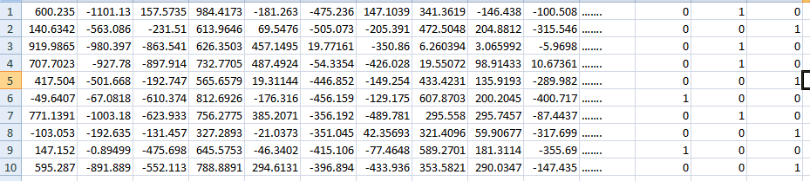

1. **CONCLUSION**

With the ease of computerized Detection and classification of cardiac arrhythmic, it has been possible to successfully diagnosis various heart diseases accurately and automatically using ANN. In out literature the ANN architecture has been explained along with the need of feature extraction, the method of learning and Classification Algorithm in an ANN. the three class of arrhythmic abnormality i.e. PVC, Fusion, Normal were able to classify the features were extracted from the QRS complex wave by using DCT algorithm which is the best algorithm as compared to other, as the results were accurate and sound. We have observed that the use of feed forward ANN with back propagation algorithm results in an excellent classifier for the Cardiac Arrhythmic diseases.

1. **REFRENCE**

[1] Devashree Joshi, R.B. Ghongade, “Artificial Neural Network based electrocardiogram pattern recognition”, IEEE Third International Conference on Computational Intelligence And Information Technology, 2013.

[2]Dayong Gao, Michael Madden, “Bayesian ANN Classifier for ECG Arrhythmias Diagnostic System,”

Proceeding of IEEE international Joint Conference On Neural Network, 2003.

[3]A. B. Ramli , P. A. ahmad, “Correlation analysis for abnormal ECG signal features extraction”, Fourth

National Conference on Telecommunication Technology, 2003

[4] Manpreet kaur, A.S. arora,” Unsupervised Analysis of Arrhythmias using K-means Clustering”,

International Journal of Computer Science And Information Technologies, 2010.

[5]A. Khemphila, V. Boonjing “Comparing performances of logistic regression, decision trees, and neural networks for classifying heart disease patients”,IEEE Conference Publication .Computer Information System and Industrial Managment Application, 2010.

[6]S.Zeybekog Lu, M. O”zkan “Classification of ECG Arrhythmia beats with Artificial Neural Networks”,

IEEE conference Publications,Biomedical Engineering Meeting, fifteenth National Digital Object Identifier,2010.

[7] MIT-BIH Database : <http://ecg.mit.edu> .

[8] A. Vishwa, M. K. Lal , S Dixit, P. Vardwa, “Classification of arrhythmic ECG Data Using Machine Learning Techniques”, International Journal Of Interactive Multimedia and Artificial Intelligence,2011.